System Architecture Document
Project Name: Xin1 Integrated Powertrain Domain Controller
Technology Owner:
Document Version: V001
Document No: Xin1_SAS_001

Change History
Version | Date | Author | Reviewer | Approver | Change description
001 | 20/07/2026 | Ratneswar Sahoo |  |  | Initial Draft

TABLE OF CONTENTS
1 Introduction 4
1.1 Document scope 4
1.2 Terminologies 4
2 System Requirements 5
2.1 System overview 5
3 System Architecture 5
3.1 Introduction 5
3.2 Block diagram/ boundary diagram 5
3.3 List of system architecture elements: 5
3.4 System Relationship 6
3.5 Dynamic behavior of the system and its elements: 7
3.6 Operation mode and its dependencies 7
4 Generic Requirements: 7
4.1 Tata Motors Generic Requirements 7
4.2 Relevant Industry Standards 7
5 System Integration plan: 8
5.1 System Integration approach 8
6 System Architecture Signoff details 8
7 Appendix: 8

Introduction

Document scope
This document describes the system architecture of the Xin1 Integrated Powertrain Unit.
The architecture defines:
- System boundary
- Architectural elements
- Internal and external interfaces
- Functional decomposition
- Allocation of system functions
- Interaction among architectural elements
- Operating modes
- Integration strategy
The architecture serves as the baseline for:
- System Design (SYS.3)
- Hardware Design
- Software Design
- Cybersecurity Concept Allocation
- Verification & Validation Activities

Terminologies
Acronym | Definition
CAN | Controller Area Network
CAN FD | Controller Area Network Flexible Data-rate
CCS2 | Combined Charging System Type 2
DTC | Diagnostic Trouble Code
EOL | End-of-Line
EVCU | Electric Vehicle Control Unit
OTA | Over-the-Air
PLC | Power Line Communication
UDS | Unified Diagnostic Services
MCU | Motor Control Unit
HV | High Voltage
LV | Low Voltage
PDU | Power Distribution Unit
HVIL | High Voltage Interlock Loop
HSD | High Side Driver
LSD | Low Side Driver
ASIL | Automotive Safety Integrity Level
FuSa | Functional Safety
EVSE | Electric Vehicle Supply Equipment
HIL | Hardware-In-Loop
Terminologies

System Requirements

System overview
The Xin1 system is an integrated electric powertrain domain control platform that combines multiple vehicle electrification functions into a single domain architecture operating on a 650 V/800 V high-voltage battery system.

System Description
The system includes:
- 250 kW traction inverter (main propulsion)
- 6 kW DC/DC converter (HV to LV conversion)
- 10 kW steering auxiliary inverter
- 10 kW brake pump auxiliary inverter
- Electric Vehicle Control Unit (EVCU)
- CCS2 charging control module
- Vehicle communication gateway (CAN/Ethernet)
The system receives HV power from the battery pack via the PDU and distributes electrical energy to traction, steering, braking and LV power networks.

Reference document

System Requirement document
Please refer to “System Requirement Document_V001”.

System Architecture

Introduction
The Xin1 System is divided into following element groups:
Control Domain
- Main CPU (Contains eVCU)
- Sub CPU
Power Domain
- Traction Inverter-1 Power board
- Traction Inverter-2 Power board
- Steering Auxiliary Inverter Power board
- Brake Auxiliary Inverter Power board
- DCDC Converter-1 Power board
- DCDC Converter-2 Power board
- DCDC Converter-3 Power board

Block diagram/ boundary diagram
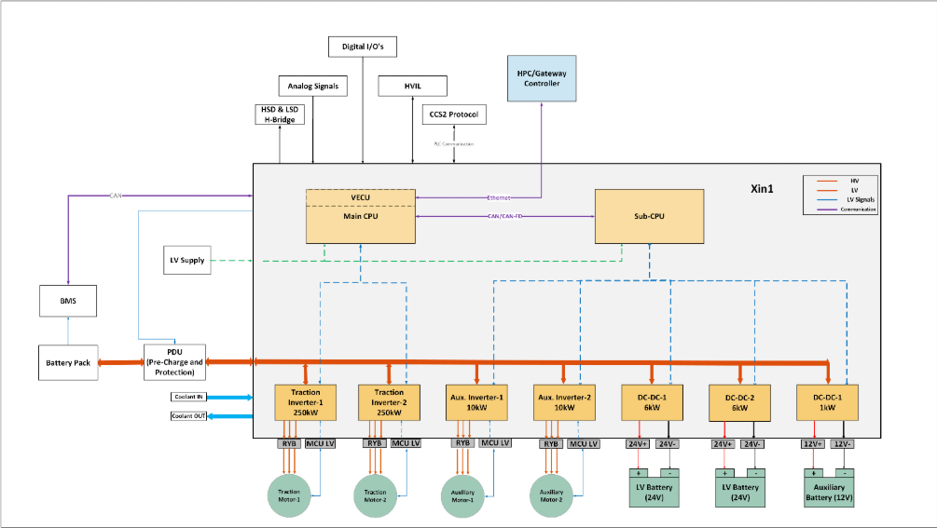

List of system architecture elements:

Element ID | Element | Sub-element
SYS_ARCH_ELE_ID_01 | Control Domain | Main CPU (Contains eVCU)
SYS_ARCH_ELE_ID_02 | Control Domain | Sub CPU
SYS_ARCH_ELE_ID_03 | Power Domain | Traction Inverter-1 power board
SYS_ARCH_ELE_ID_04 | Power Domain | Traction Inverter-2 power board
SYS_ARCH_ELE_ID_05 | Power Domain | Steering Auxiliary Inverter power board
SYS_ARCH_ELE_ID_06 | Power Domain | Brake Auxiliary Inverter power board
SYS_ARCH_ELE_ID_07 | Power Domain | DCDC Converter-1 (6kW) power board
SYS_ARCH_ELE_ID_08 | Power Domain | DCDC Converter-2 (6kW) power board
SYS_ARCH_ELE_ID_09 | Power Domain | DCDC Converter-3 (1kW) power board
SYS_ARCH_ELE_ID_10 | External Interface | HVIL
SYS_ARCH_ELE_ID_11 | External Interface | CCS2 charging
SYS_ARCH_ELE_ID_12 | External Interface | Analog inputs
SYS_ARCH_ELE_ID_13 | External Interface | Digital inputs/outputs
SYS_ARCH_ELE_ID_14 | External Interface | HSD/LSD
SYS_ARCH_ELE_ID_15 | External Interface | Battery Pack via PDU
SYS_ARCH_ELE_ID_16 | External Interface | Cooling System
List of System Architecture elements

System Relationship

Relationship of system elements (including interfaces and interactions)
Element ID | Element | Sub-element | Category (SW/HW/Both) | Function | Related with Element/SW | Type of interface (Internal/External) | Interface Interaction description | Detailed Description
SYS_ARCH_ELE_01 | Control Domain | Main CPU (Contains EVCU) | Both | Vehicle control, state management, diagnostics, safety management | Sub CPU | Internal | CAN Communication | EVCU exchanges commands, diagnostics, watchdog status, and safety monitoring information with Sub CPU.
 |  |  |  | Torque coordination | Traction Inverter-1 | Internal | CAN Communication | EVCU transmits propulsion enable, torque request, derating command and receives motor feedback and inverter diagnostics.
 |  |  |  | Torque coordination | Traction Inverter-2 | Internal | CAN Communication | EVCU transmits propulsion commands and receives inverter status and fault information.
 |  |  |  | Steering control coordination | Steering Auxiliary Inverter | Internal | CAN Communication | EVCU sends steering enable and operating mode commands and receives diagnostics/status.
 |  |  |  | Brake system coordination | Brake Auxiliary Inverter | Internal | CAN Communication | EVCU sends compressor requests and receives motor status, faults and operational feedback.
 |  |  |  | LV power management | DCDC Converter-1 | Internal | CAN Communication | EVCU supervises converter operation and receives voltage/current/temperature diagnostics.
 |  |  |  | LV power management | DCDC Converter-2 | Internal | CAN Communication | EVCU supervises converter operation and receives status information.
 |  |  |  | Auxiliary battery charging | DCDC Converter-3 | Internal | CAN Communication | EVCU supervises 12V charging operation and diagnostic information.
SYS_ARCH_ELE_02 | Control Domain | Sub CPU | Both | Safety supervision | EVCU Main CPU | Internal | CAN Communication | Sub CPU performs supervision, diagnostics and watchdog monitoring of VECU.
SYS_ARCH_ELE_03 | Power Domain | Traction Inverter-1 power board | Both | Motor drive control | Traction Motor-1 | External | 3-Phase Power Interface (RYB) | Converts HV DC bus voltage into controlled 3-phase AC power for propulsion motor.
SYS_ARCH_ELE_04 | Power Domain | Traction Inverter-2 power board | Both | Motor drive control | Traction Motor-2 | External | 3-Phase Power Interface (RYB) | Converts HV DC bus voltage into controlled 3-phase AC power for propulsion motor.
SYS_ARCH_ELE_05 | Power Domain | Steering Auxiliary Inverter power board | Both | Steering pump motor control | Steering Pump Motor | External | 3-Phase Power Interface (RYB) | Controls steering motor speed and torque according to vehicle command.
SYS_ARCH_ELE_06 | Power Domain | Brake Auxiliary Inverter power board | Both | Brake compressor motor control | Brake Compressor Motor | External | 3-Phase Power Interface (RYB) | Controls brake compressor motor operation and pressure generation.
SYS_ARCH_ELE_07 | Power Domain | DCDC Converter-1 (6kW) power board | Both | LV power supply, LV battery charging | Vehicle 24V Loads | External | 24V Power Output | Supplies regulated 24V power to vehicle ECUs, loads and charges 24V LV battery.
SYS_ARCH_ELE_08 | Power Domain | DCDC Converter-2 (6kW) power board | Both | LV power supply | Vehicle 24V Loads | External | 24V Power Output | Provides additional 24V supply capacity and redundancy.
SYS_ARCH_ELE_09 | Power Domain | DCDC Converter-3 (1kW) power board | Both | Auxiliary battery charging | 12V loads | External | 12V Power Output | Charges auxiliary battery and supplies low power loads.
SYS_ARCH_ELE_10 | Vehicle Interface | HVIL | HW | High voltage safety monitoring | EVCU Main CPU | External | Digital Safety Signal | Indicates continuity of HV interlock loop. Loss of HVIL triggers safety action.
SYS_ARCH_ELE_11 | Vehicle Interface | CCS2 charging | Both | Charging communication | EVCU Main CPU | External | PLC Communication | Supports ISO 15118 and CCS2 charging communication with EVSE.
SYS_ARCH_ELE_12 | Vehicle Interface | Analog Inputs | HW | Vehicle sensing | EVCU Main CPU | External | Analog Interface | Inputs such as pedal sensors, pressure sensors, temperature sensors and resolver.
SYS_ARCH_ELE_13 | Vehicle Interface | Digital Inputs/Outputs | HW | Vehicle control | EVCU Main CPU | External | Digital IO | Wake-up, ignition, interlock and control signals.
SYS_ARCH_ELE_14 | Vehicle Interface | HSD/LSD | HW | Actuator control | EVCU Main CPU | External | High Side/Low Side Driver Interface | Used for relay, actuator and auxiliary load control.
SYS_ARCH_ELE_15 | External Power Source | Battery Pack via PDU | HW | HV power source | Internal HV Distribution Bus | External | HV Power Interface | Provides HV DC power to all Xin1 power conversion and propulsion aggregates.
SYS_ARCH_ELE_16 | Thermal Management | Cooling System | HW | Heat removal | All Power Domain Elements | External | Coolant Flow Interface | Removes heat from traction inverters, auxiliary inverters and DCDC converters through coolant circulation.

Allocation matrix

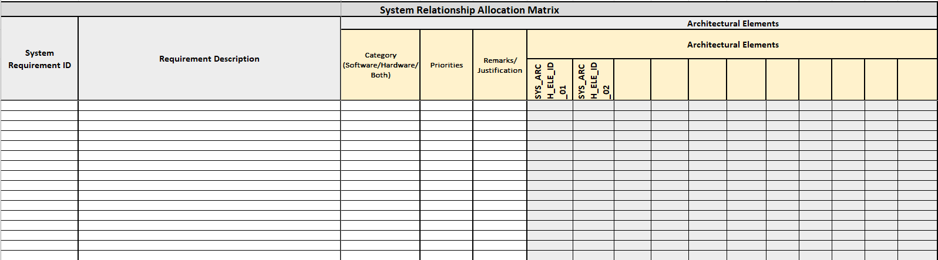

Dynamic behavior of the system and its elements:

Operation mode and its dependencies
Operation mode | State | Command | Time (msec) | Description
Initialization | Init | Ignition ON | <500 | System startup and self-test
Idle | Standby | Wake-up | Continuous | Waiting for drive request
Drive | Ready | Drive enable | <100 | Torque generation enabled
Charging | Charge | EVSE connect | Continuous | Charging operation active
Derating | Derate | Fault active | <50 | Reduced performance mode
Fault | Safe state | Critical fault | <100 | Safe state active
Off | Shutdown | Ignition off | <1000 | Controlled shutdown
Operation modes

Generic Requirements:

Tata Motors Generic Requirements

Document Number | Definition
List of Tata motors generic requirements

Relevant Industry Standards
Document Number | Definition
ISO 26262 | Functional Safety
ASPICE v4.0 | Automotive Process Assessment
ISO 21434 | Automotive Cybersecurity
List of Relevant Industry Standards

System Integration plan:

System Integration approach

System Integration steps and their sequence

Step | Description
List of System Integration and their sequence

System Architecture Signoff details

Sr.no | Function | Name | Designation
1
2
3
4
List of stakeholder for signoff

Appendix:

